# From Surveillance to Promotion: Inclusive Oral Health Monitoring for People with Disabilities in Ireland

# Bursary application team:

Katrina Byrne, Blánaid Daly, Philip McCallion, Mary McCarron, Caoimhin Mac Giolla Phadraig.

**Corresponding applicant:**

Katrina Byrne

Kbyrne1@tcd.ie

# Background

Oral health is a cornerstone of general health and wellbeing. For adults with intellectual disabilities (ID), the burden of oral disease is disproportionately high. They are twice as likely to lose all their teeth (1,2) compared to the general population (3) and more likely to experience untreated dental caries and periodontal disease (1,2) and less likely to receive restorative treatment(7). Oral disease in this population often results in tooth extraction and functional disability, with limited rehabilitation.

Yet, despite these urgent needs, people with ID remain systematically excluded from oral health surveillance and research (4,5), resulting in a lack of representative data to inform services and policy. Traditional oral health indices, such as DMFT or CPI, require probing, drying and lengthy examinations. These methods are unsuitable for many people with ID, leading to their underrepresentation in national surveys and research. Without valid and inclusive data, oral health inequalities cannot be identified or addressed.

To meet this challenge, our research team developed the Modified Oral Status Survey Tool (MOSST) an innovative, accessible, reliable and feasible oral health assessment tool designed for use by trained non-dental professionals. The MOSST was rigorously validated and successfully implemented in Wave 5 of IDS-TILDA, where 469 adults with ID participated in the largest inclusive oral health survey internationally (3).

The MOSST now represents more than an assessment tool, it is a vehicle for oral health promotion, enabling services to identify needs, design preventive programs and advocate for resources. Through this bursary, we will extend the MOSST from research into practice by training frontline staff to use the tool, interpret results, and implement targeted oral health promotion strategies in collaboration with people with ID. In doing so, we will strengthen communication, inclusion and equity in oral health, fully aligned with OHPRG’s 2025 theme *“Communication Strategies for Better Oral Health.”*

# Aims and Objectives

The aim of this application is to:

* Briefly summarise the development of the MOSST
* Outline how the MOSST can be used using sample cases
* Outline intended use of this bursary to support training of dental and non-dental staff in the use of the MOSST to identify preventive and reparative treatment needs.

# Materials and Methods

The project will build on the robust MOSST infrastructure already developed and tested previously in IDS TILDA (3).

**Figure 1: The MOSS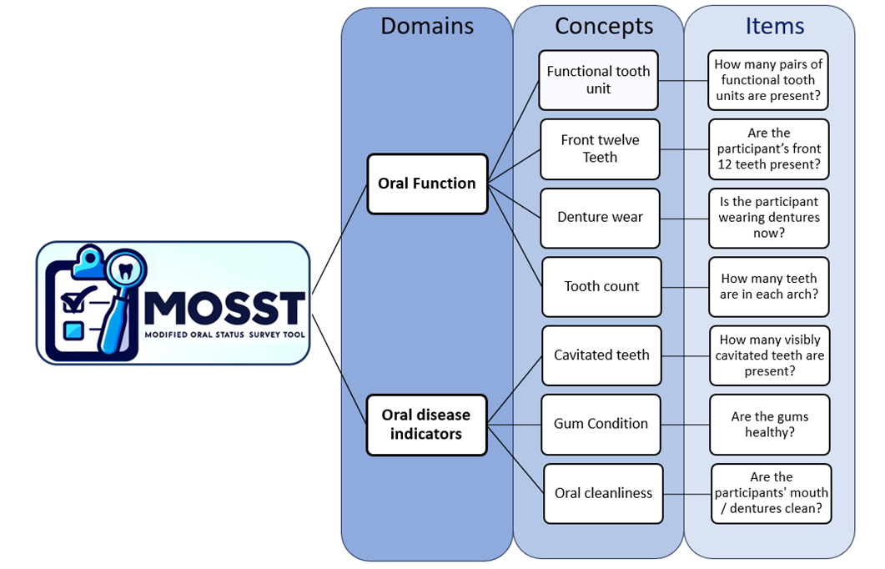T**

## Training delivery:

Training will be delivered through a blended model, combining interactive in-person workshops with online learning modules hosted on *EdApp*. This flexible approach allows staff to engage with materials at their own pace while also benefiting from hands-on practice and peer discussion.

The training content will cover:

* The MOSST administration protocol and scoring criteria.
* Effective communication and consent strategies tailored for people with ID.
* Calibration and practical skill development, using clinical photographs, peer practice, to ensure accuracy and confidence in assessment.

In practice, this means staff will not only learn to score the MOSST accurately but also gain the skills to promote daily oral health through early identification of problems, preventive support, and timely referral.

## Resources:

Resources will include a full suite of training materials, such as a structured MOSST training protocol, easy-read guides and demonstration videos. A key feature of this project is that people with ID will co-teach alongside the project leads, ensuring that training reflects lived experience, promotes reasonable adjustments and embeds the correct approach to inclusive oral health assessment. In addition, each trainee will be equipped with a MOSST kit containing the essential tools required for oral health assessment (mirror, gloves, torch, scoring sheets). These resources will support high-quality, consistent assessments and facilitate the integration of the MOSST into routine service practice.  
Implementation:

ID services will be approached to nominate staff to attend training. Trainees will complete baseline MOSST assessments within their service to map local oral health needs, following training and calibration.   
Data Use:

All MOSST data will be anonymised and collated at service level. These data will be used to guide local quality improvement. For example, where high levels of plaque or untreated caries are identified, services can prioritise daily toothbrushing support, dietary interventions, or referral to dental care. As part of the training programme, a follow-up session will be held with an Oral Health Promotion team. This session will support trainees to interpret their results and explore how findings can be translated into practical actions. This will include linking with existing initiatives such as the *Keep My Teeth* project and identifying ways to strengthen oral health support at home and in care settings. In this way, MOSST becomes both a surveillance tool and an active driver of oral health promotion at local and national levels.

Evaluation:

Evaluation will focus on both the effectiveness of training and the wider impact of MOSST as a health promotion tool. Trainee competence will be assessed through calibration scores, observed practice, and self-reported confidence in using the MOSST. Importantly, the evaluation will also track how MOSST data are being used to inform local oral health promotion initiatives. Finally, the follow-up session with Oral Health Promotion teams will be evaluated to measure how effectively trainees link MOSST findings with initiatives such as the *Keep My Teeth* project and how these influences oral health support provided at home and in care settings. Evaluation will therefore capture both technical accuracy and the extent to which trainees apply the MOSST findings to strengthen everyday oral health promotion within ID support services.  
Dissemination:

Findings will be shared at the OHPRG annual conference, with posters and publications targeting oral health promotion and disability audiences.

# Results

Evidence from IDS-TILDA demonstrates that the MOSST is both robust and feasible as an inclusive oral health assessment tool. Importantly, it was delivered by research nurses with no dental training, proving its transferability to frontline staff (3). This demonstrates the unique opportunity to embed the MOSST within services as a practical oral health promotion tool.

**Figure2: MOSST Wave5 IDS TILDA results**

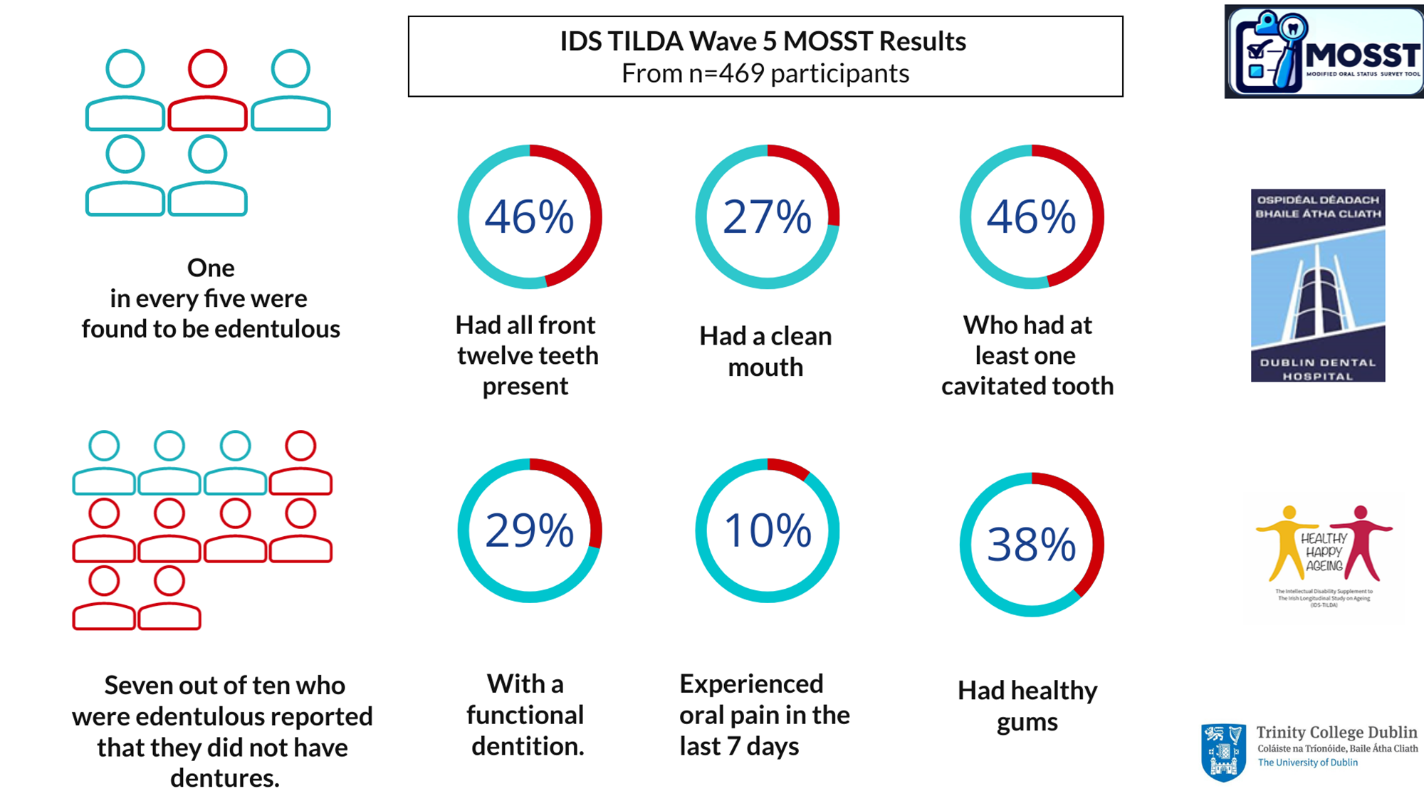

# Discussion and Conclusion

This project represents a unique opportunity to translate innovation into practice by positioning MOSST as an oral health promotion intervention for people with ID. Traditional approaches have relied heavily on education campaigns, but often without robust data to target needs or evaluate impact. The MOSST changes this by equipping services with a simple, low-cost, inclusive tool that both measures oral health and drives responsive action. At the service level, staff will gain skills, confidence, and resources to support daily oral care, deliver preventive interventions and communicate oral health needs effectively. At the national level, aggregated MOSST data can inform oral health policy, support the implementation of *Smile agus Sláinte* and the National Human Rights Strategy for Disabled People 2025–2030, and strengthen advocacy for equitable dental services. By supporting training, resources and co-teaching with people with ID, this bursary will act as a catalyst to embed the MOSST within disability services, ensuring that oral health promotion is inclusive, evidence-based and sustainable.

# Acknowledgements

We acknowledge the IDS-TILDA participants, Trinity Centre for Ageing and Intellectual Disability, PPI and expert panels, School of dental science Trinity College Dublin in the development of the MOSST.

# Costs

Budget plan for bursary funding (€1,000):

|  |  |
| --- | --- |
| PPI involvement in training and printing training resources | €200 |
| Training space and resources | €200 |
| MOSST toolkits for trainees (mirrors, gloves, torches, disposable items): | €300 |
| Evaluation materials and software licenses (survey tools, data collation): | €200 |
| Dissemination | €100 |
| Total: | €1,000 |