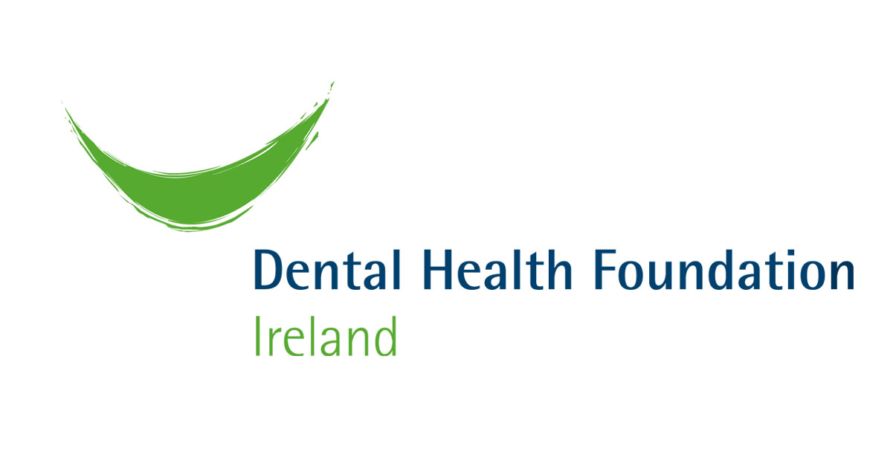

Oral Health and the Older Person

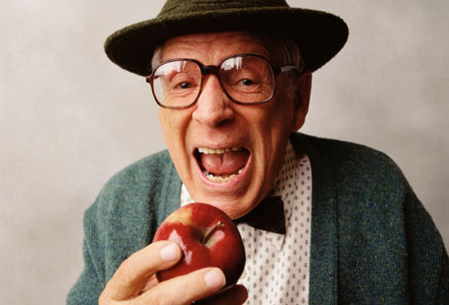

Briefing for Older and Bolder, December 2011

The Role of the Dental Health Foundation

The Dental Health Foundation is a unique organisation within the oral health promotion sector. It provides strong advocacy as an independent voice to ensure that both existing and new and emerging oral health matters are communicated appropriately and effectively using a multi-strategy approach.

The DHF acts as a central facilitator and strategist in placing oral health issues and solutions on the national health agenda. It is a valued resource within the healthcare sector for advice and tools to promote best oral health practices, and increasing awareness amongst the public empowering them to make healthier oral and general health lifestyle choices. It focuses its energy on strengthening community action by responding to needs and working with communities to put in place appropriate information and education programmes. The DHF continually supports innovation and development in the delivery of oral care prevention measures arising from scientific research conducted both nationally and internationally.

The Foundation has and continues to develop oral health information programmes for children; both early childhood and school-based initiatives, oral cancer suffers, people with special needs, older people and the general population. In pursuing these goals, the Foundation will continue to work closely with its key stakeholders, i.e. the Department of Health, the HSE, health professionals, relevant agencies, the general public, consumer groups and the commercial sector.

The Foundation’s contribution in advancing oral health at National level is formerly recorded in the Department of Health and Children’s Commissioned Report, the Review of the National Health Promotion Strategy (2004). The Foundation also achieved considerable recognition internationally by the World Health Organization, the National Institute for Health USA, the Oral Health Promotion Research Group UK and Council of European Chief Dental Officers for its work as described in the Report’s details.

The Importance of Oral Health Promotion
The burden of chronic diseases is expected to rise dramatically in the Republic of Ireland between 2007 and 2020 (IPH 2010).

The available evidence shows that oral diseases share important common risk factors with the four leading chronic diseases - cardiovascular diseases, cancer, chronic respiratory diseases and diabetes - including unhealthy diet, tobacco use, and excessive alcohol consumption. Therefore good oral health is of vital importance to the general health of everyone in Ireland. Consequently, oral health promotion and preventive measures are important approaches to improving overall health and reducing costs.

Oral health is important at all stages of life. The current cohort of older Irish people has low expectations in relation to their oral health and most only attend the dentist when they require treatment. Older people may suffer from tooth loss, affecting their quality of life. Ill fitting dentures can affect their ability to eat and speak properly. Older people in long-term care facilities are at particular risk of complications from poor oral health because of frailty, poor health and increased dependence on others for personal care (HSE, 2010).

In the editorial ‘It’s Never Too Late: Health Promotion and Illness Prevention in Older Persons’ it states there is evidence that healthy lifestyle habits postpone and reduce morbidity. Health promotion and illness prevention range from simple but highly effective interventions to screening. Additionally, Geriatricians need to be active promoters of the concepts of preventative medicine and a healthy lifestyle for older persons. (Morley et al, 2002)

Oral health systems should better match the needs of older people, including the functionally independent, the frail and the functionally dependent. Greater understanding is needed regarding diet and nutrition in older age and how tooth loss and the status of the oral cavity can result in inadequate nutrition and weight loss. Xerostomia or ‘Dry Mouth’ which can occur as a result of medication or from an underlying health condition has a negative effect on oral function and quality of life. There is a need for training of health professionals for better service and care based on multi-disciplinary and holistic approaches. The role of caregivers is instrumental in promoting the health of older people. (WHO 2006).

Food poverty has a significant impact on oral health and general health. The Healthy Food for All Report (2009) found an older woman would spend 25% of her pension purchasing healthy food in her local convenience store, but only 13% if she was able to shop in a discount store. Research on food poverty shows people on low incomes rely predominately on local stores due to lack of transport and other issues accessing multiple supermarkets and discount stores. (HHFA 2009; Friel et al, 2004) Indeed alternatives to public transport are increasingly unaffordable to many. Those on low incomes eat less well, often paying more for food. In addition, they have to endure poorer food quality and, as a result, suffer more diet-related ill health.

Reducing health inequalities is a matter of fairness and social justice. Creating a fairer society is fundamental to improving the health of the whole population and ensuring a fairer distribution of good health (The Marmot Review 2010).

Ireland as a member state of WHO signed the Bangkok Charter for Health Promotion in a Globalized World. The charter identifies actions, commitments and funds that are needed to address health determinants through health promotion (WHO 2005). The World Health Assembly resolution A60/16 Oral Health: action plan for promotion and integrated disease prevention pinpoints what is required for oral health (WHO 2007).

At the 7th WHO Global Conference on Health Promotion - towards integration of oral health (Nairobi, Kenya 2009) there was a call on all governments and stakeholders to respond urgently to this Call to Action and the strategies and actions that follow, including:
- To use the untapped potential of health promotion
- To make health promotion principles integral to the policy and development agenda
- To develop effective and sustainable delivery mechanisms (Peterson et al 2010)

Therefore it is imperative that there is continued investment in all areas of health promotion and prevention in Ireland.
Oral health is central to the health and well being of older people. Investing in oral health should not only be calculated in monetary terms but also considered as an investment in empowering individuals through increased self-esteem, supporting communication, nutrition and improving quality of life.
The Dental Health Foundation welcomes the opportunity to provide input and to play an important role in securing and promoting the rights of older people in oral health. DHF supports the ‘Make Home Work’ campaign particularly regarding older people as active managers of their own health, through effective oral health promotion messaging and recognising that ‘health is more than medicine alone’. The Foundation looks forward to developing the oral health agenda for older people with all stakeholders into the future.
http://www.dentalhealth.ie/olderpeople/
http://www.dentalhealth.ie/dentalhealth/

References:

Friel et al (2004) Food Poverty and Policy

Healthy Food For All (2009) Policy Briefing – The Affordability of healthy eating for low income households

Institute of Public Health in Ireland (2010) Making Chronic Conditions Count: Hypertension, Stroke, Coronory Heart Disease, Diabetes

Marmot et al (2010) Fair Society, Healthy Lives – The Marmot Review

Morley, JE et al (2002) It's Never Too Late: Health Promotion and Illness Prevention in Older Persons. J Gerontol: Med Sci 2002;57A:M338-M342.

Oral Health Promotion Team, HSE Dublin North East, LHO Cavan/Monaghan, Meath & Louth, 'Healthy Lifesmiles' - An Oral Health Information Programme for Carers of Older People (2010)

World Health Organistion (2005) The Bangkok Charter for Health Promotion in a Globalized World

World Health Organistion (2006) Oral Health in Aging Societies – Integration of oral health and general health

World Health Organization (2007) Sixtieth World Health Assembly WHA60.17, Geneva

